**Account Creation**

@startuml

(*) -down-> "Create Account"

"Create Account" -down-> "Enter Email"

if "Validate Email" then

-down-> [valid email] "Enter Password"

if "Validate Password" then

-down-> [valid password] "Confirm Password"

if "Same Entry" then

-down-> [entries are same] ===Confirm_Email===

===Confirm_Email=== -down-> "Send Confirmation Email"

===Confirm_Email=== -down-> "Confirm Email"

else

-up-> [entries not same] "Enter Password"

endif

else

-up-> [invalid password] "Enter Password"

endif

else

-up-> [invalid email] "Enter Email"

endif

"Send Confirmation Email" -down-> ===Account_Creation===

"Confirm Email" -down-> ===Account_Creation===

===Account_Creation=== -down-> "Account Created"

"Account Created" -down-> "Home Page"

“Home Page” -down-> (*)

@enduml

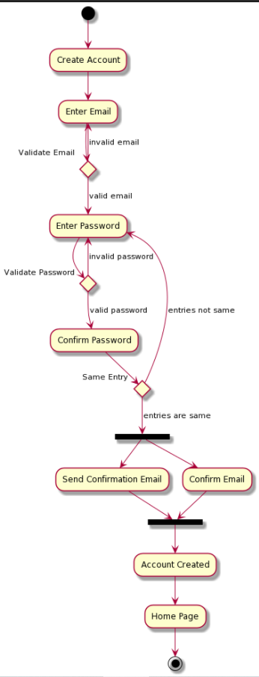

**Log in**

@startuml

(*) -down-> "Log in"

"Log in" -down-> "Enter Email"

-right-> if "Validate Email" then

-down-> [valid email] "Enter Password"

-down-> if "Validate Password" then

-down-> [valid password] "Fetch User Information"

"Fetch User Information" -down-> "Home Page"

"Home Page" -down-> (*)

else

-right-> [invalid password] if "Reset Password" then

-right-> [yes] "Send Reset Password Email"

"Send Reset Password Email" -down-> "Take Link"

"Take Link" -down-> "Enter New Password"

if "Valid Password" then

-down-> [yes] "Confirm Password"

if "Same Entry" then

-down-> [yes] "Change to New Password"

"Change to New Password" -up-> "Log in"

else

-up-> [no] "Confirm Password"

endif

else

-up-> [no] "Enter Password"

endif

else

-up-> [no] "Enter Password"

endif

endif

else

[invalid email] if "New User" then

-right-> [yes] "Create Account"

"Create Account" -right-> (*)

else

-up-> [no] "Enter Email"

endif

endif

@enduml

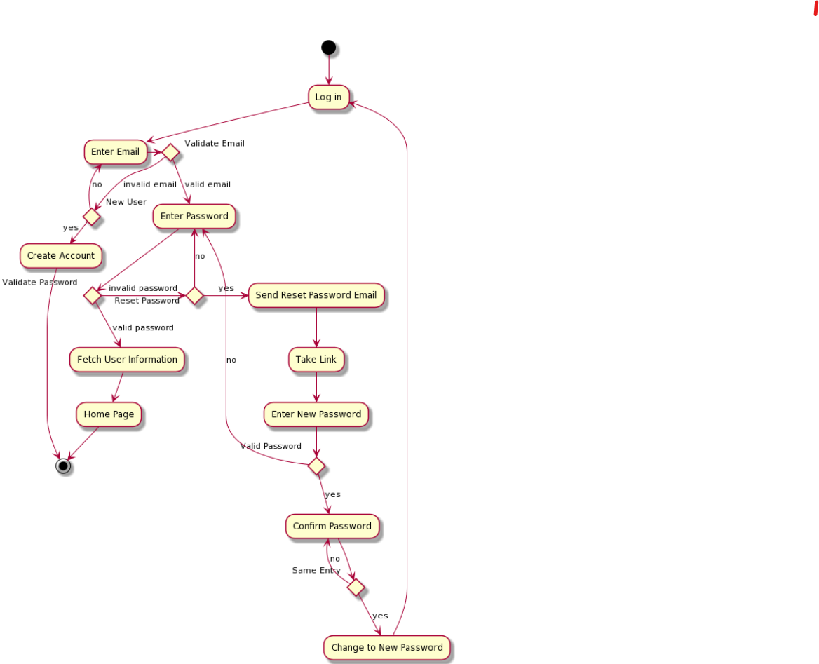

**Create Animal**

@startuml

(*) -down-> "Create Animal"

"Create Animal" -down-> "Choose Animal"

"Choose Animal" -down-> "Name Animal"

"Name Animal" -down-> "Choose Traits"

"Choose Traits" -down-> "Write Description"

if "Confirm Creation" then

-down-> [yes] "Load Animal Into Database"

else

-down-> [no] "Cancel Creation"

"Cancel Creation" -down-> "Home Page"

endif

"Load Animal Into Database" -down-> "Animal Loaded"

"Animal Loaded" -down-> "Home Page"

"Home Page" -down-> (*)

@enduml

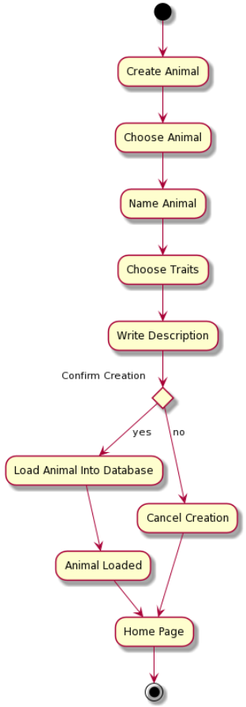

**Share Animal**

@startuml

(*) -down-> "Share Animal"

"Share Animal" -down-> "Choose Animal"

"Choose Animal" -down-> "Choose Friend"

"Choose Friend" -down-> "Attach Message"

"Attach Message" -down-> "Confirm Information"

if "Confirm" then

-down-> [yes] "Upload Animal to Friend"

"Upload Animal to Friend" -down-> "Send Notification to Friend"

"Send Notification to Friend" -down-> "Home Page"

"Home Page" -down-> (*)

else

-down-> [no] "Cancel Sharing"

"Cancel Sharing" -down-> "Home Page"

"Home Page" -down-> (*)

endif

@enduml

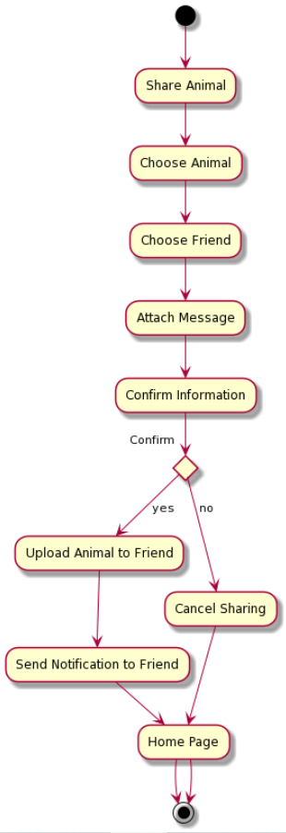

**View User Animal**

@startuml

(*) -down-> "View User Animal"

"View User Animal" -down-> "Fetch User Animal Names"

"Fetch User Animal Names" -down-> "Choose Animal"

"Choose Animal" -down-> "Fetch Chosen Animal Info"

"Fetch Chosen Animal Info" -down-> "Display Animal Info"

"Display Animal Info" -down-> (*)

@enduml

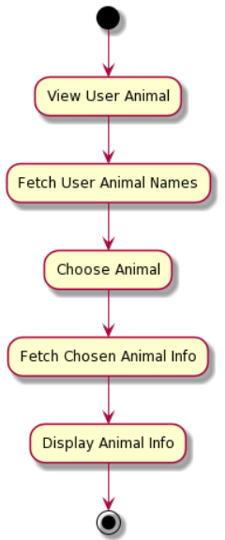

**View All Shared Animals**

@startuml

(*) -down-> "View All Shared Animals"

"View All Shared Animals" -down-> "Fetch Shared Animals List"

"Fetch Shared Animals List" -down-> "Display Shared Animals"

"Display Shared Animals" -down-> (*)

@enduml

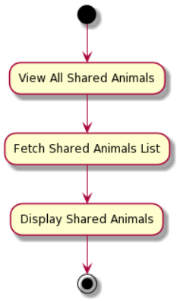

**Feed Animal**

@startuml

(*) -down-> "Feed Animal"

"Feed Animal" -down-> "Select Food"

"Select Food" -down-> "Confirm Food"

"Confirm Food" -down-> "Attempt Feeding"

-down-> if "Feeding Success" then

-down-> [yes] "Display Happy Animal"

"Display Happy Animal" -down-> "Update Hunger Stat"

"Update Hunger Stat" -down-> "Home Page"

"Home Page" -down-> (*)

else

-down-> [no] "Cancel Feeding"

"Cancel Feeding" -down-> "Display Angry Animal"

"Display Angry Animal" -down-> "Update Stats"

"Update Stats" -down-> "Home Page"

endif

@enduml

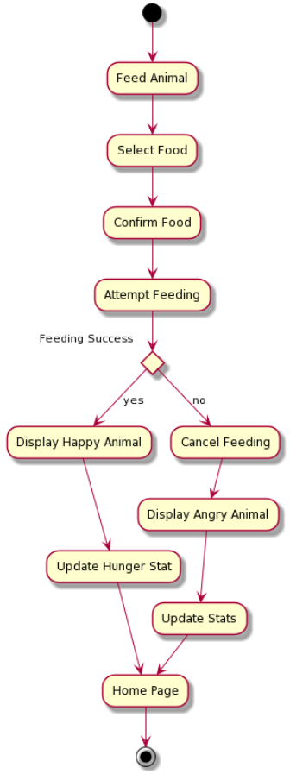

@startuml

(*) -down-> "Add a Friend"

"Add a Friend" -down-> "Enter Email"

if "Existing User" then

-down-> [yes] "Send Friend Request"

"Send Friend Request" -down-> "Home Page"

"Home Page" -down-> (*)

else

-down-> [no] "Cancel Adding Friend"

"Cancel Adding Friend" -down-> "Home Page"

endif

@enduml

